DO MORE GUNS REDUCE CRIME?



BUAN 6312.001

APPLIED ECONOMETRICS AND TIME SERIES ANALYSIS

GROUP PROJECT

NOV 2020

Syamala Anisha Katta- SXK190002

Akshata Bodhankar

Garima Tuteja

Karthik Mahant Kattula

CONTENTS

1. INTRODUCTION 3
2. VARIABLE DEFINITIONS
3. OBSERVATIONS FROM DATA
4. UNDERSTANDING DATA
5. DESCRIPTIVE ANALYSIS

INTRODUCTION

**Do more Guns reduce Crime?**

The impact of guns on crime in America has triggered a lot of public debate. Many strongly believe that state laws enabling citizens to carry concealed handguns had reduced crime. According to this view, gun control laws take away guns from lawabiding citizens, while would-be criminals ignore those leaving potential victims defenseless. Following this view, The National Rifle Association (NRA) and many politicians across the country advance the cause of greater freedom to carry guns.

As a result, many states in the United States have passed right-to-carry laws (also known as a shall-issue laws). A Shall-issue law is one that requires that governments issue concealed carry handgun permits to any applicant who meets the necessary criteria. These criteria are the applicant must be an adult, have no significant criminal record, and no history of mental illness and successfully complete a course in firearms safety training (if required by law). If these criteria are met, the granting authority has no discretion in the awarding of the licenses, and there is no requirement of the applicant to demonstrate "good cause".

We have analysed the historical data on crime in the U.S to answer the question “Do shall-issues law reduce crime-or not.

**GUNS DATASET**

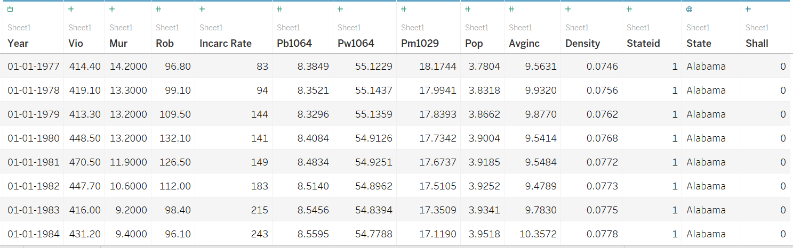

Guns is a balanced panel of data on 50 US states, plus the District of Columbia (for a total of 51 “states”), by year for 1977 – 1999. Each observation is a given state in a given year. There is a total of 51 states × 23 years = 1173 observations.

The state names corresponding to each state Id are as follows:

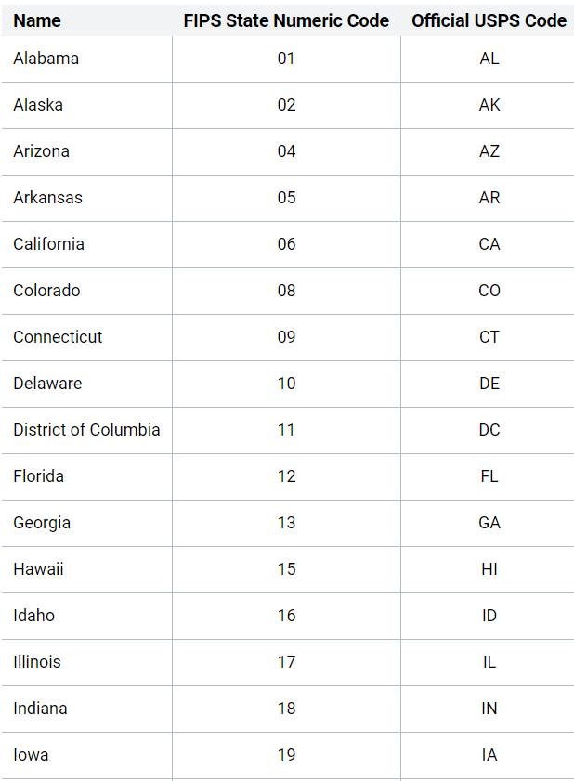

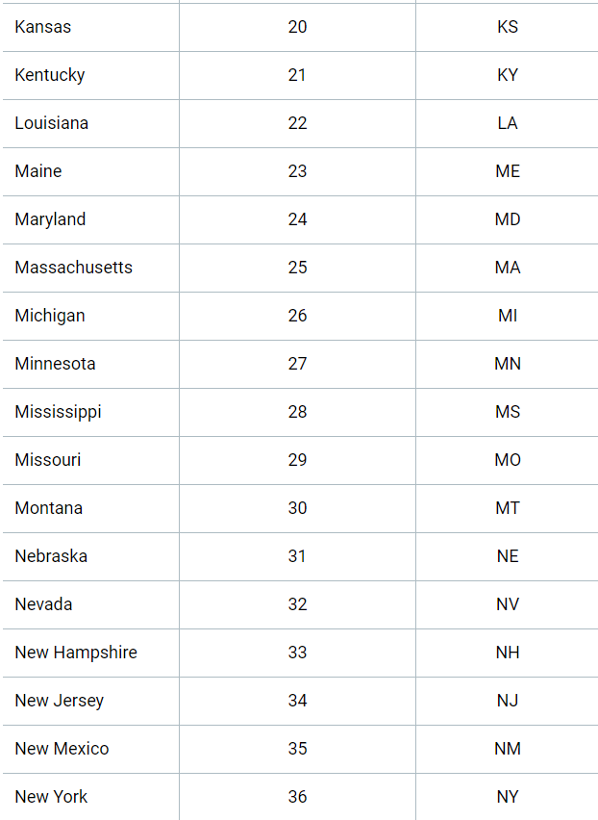

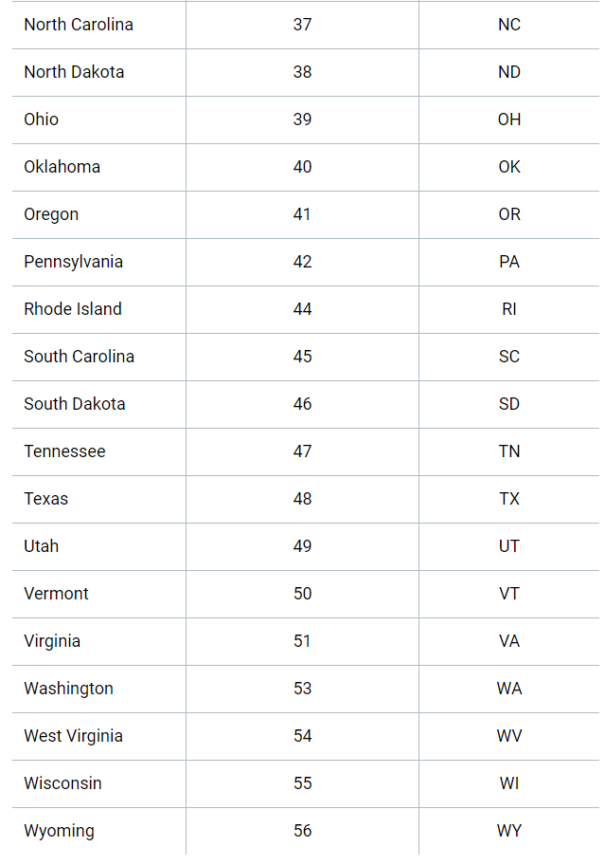

**VARIABLE DEFINITIONS**

|  |  |
| --- | --- |
| **Variable** | **Definition** |
| *vio* | violent crime rate (incidents per 100,000 members of the population) |
| *rob* | robbery rate (incidents per 100,000) |
| *mur* | murder rate (incidents per 100,000) |
| *shall* | = 1 if the state has a shall-carry law in effect in that year  = 0 otherwise |
| *incarc_rate* | incarceration rate in the state in the previous year (sentenced  prisoners per 100,000 residents; value for the previous year) |
| *density* | population per square mile of land area, divided by 1000 |
| *avginc* | real per capita personal income in the state, in thousands of dollars |
| *pop* | state population, in millions of people |
| *pm1029* | percent of state population that is male, ages 10 to 29 |
| *pw1064* | percent of state population that is white, ages 10 to 64 |
| *pb1064* | percent of state population that is black, ages 10 to 64 |
| *stateid* | ID number of states (Alabama = 1, Alaska = 2, etc.) |
| *year* | Year (1977-1999) |

**Expected impact of variables on violent crime rates according to economic theory:**

• SHALL: Introduction of Shall-carry law should reduce the crime rate and therefore will have an inverse relation with the crime rate.

• INCARC_RATE: Increase in Incarceration rate should reduce the crime rate and therefore will have an inverse relation with the crime rate.

• DENSITY: The role of population density in the generation or suppression of crime has been the subject of debate for decades. So, we can say that it can either increase or decrease the crime rate.

• AVGINC: The real per capita personal income in the state should reduce the crime rate, therefore an inverse relation.

• POP: More the state population, more the chances violent crime rate. So, POP will have a positive relation with VIO.

•PM1029: Having more male population between ages 10 and 29 increase the chances of crime. Therefore, it will have positive relation with crime rate.

• PW1064 and PB1064: The effect of these two variables, according to economic theory, are highly contrasting. The difference because of different racial groups effect the crime rate differently and are debatable. The effect of population of blacks increase the crime rate as compared to population of whites. Competitive society in which there is an inequality in the distribution of goods, those groups with limited or restricted access to goods will be more likely to turn to crime.

**OBSERVATIONS FROM DATA:**

1. **Population and Violent crime rate in each state**

We have added state names column to the given data in order to increase our understanding of the data and used this column as a geographical representation in tableau.

From the visualisation we can observe that the states with high population are California, North Carolina followed by South Dakota and states with high violent crime rates are Florida, Georgia followed by California.

So we understand that the crimes are not significantly taking place in states having high population.

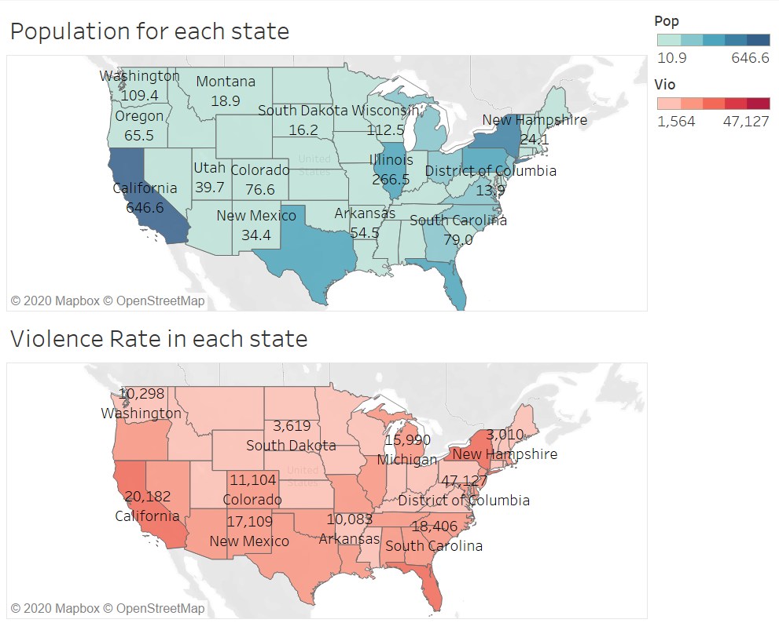

1. **Murder rates in shall law issued states and non issued states**

**1977**

In this visualisation we see that the number of states that have issued the shall-law (represented by brown colour) is less and the number of states that have not issued the law is high.

We observe that the state of District of Columbia has the highest murder rate

In accordance with our belief that issuing the shall law reduces crime, we can observe that the shall law issued states have less murder rate.

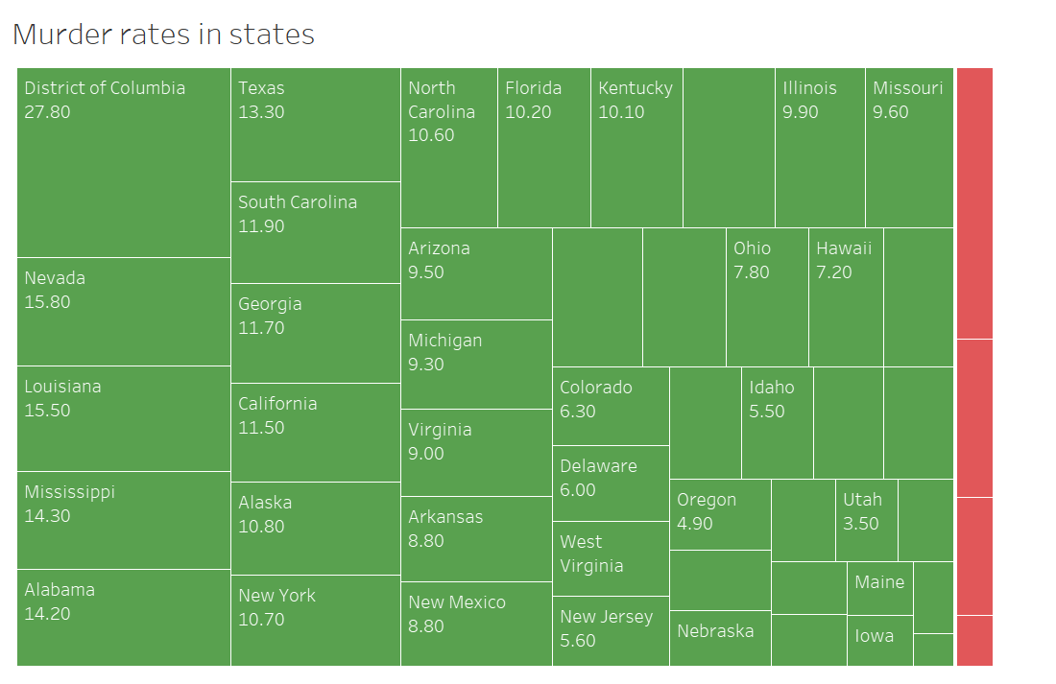

**1999**

This visualisation is the same as the above but for year 1999 when the shall law has been widely issued.

Here also the highest murder rate is in the state of District of Columbia and yet the law has not been issued for this state.

Almost half of all the states have got the law and for instance we can look at Georgia where previously in the year of 1977 the murder rate was around 11.7 and has reduced to half which is 7.50 after the shall law was issued.

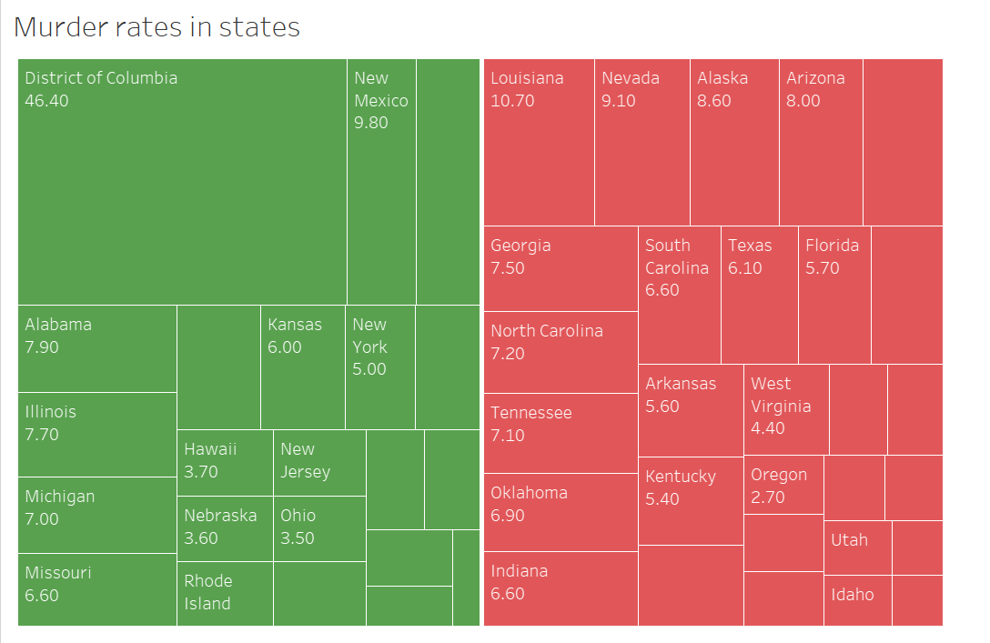

1. **Robbery rates in shall law issued states and non issued states**

**1977**

Similar to the previous visualisations, now let us look at the robbery rates before and after shall law was issued.

In 1977 we see that District of Columbia again has the highest robbery rate of a high value(964.5).

We see that only 4 of the 51 states have been issued the shall law.

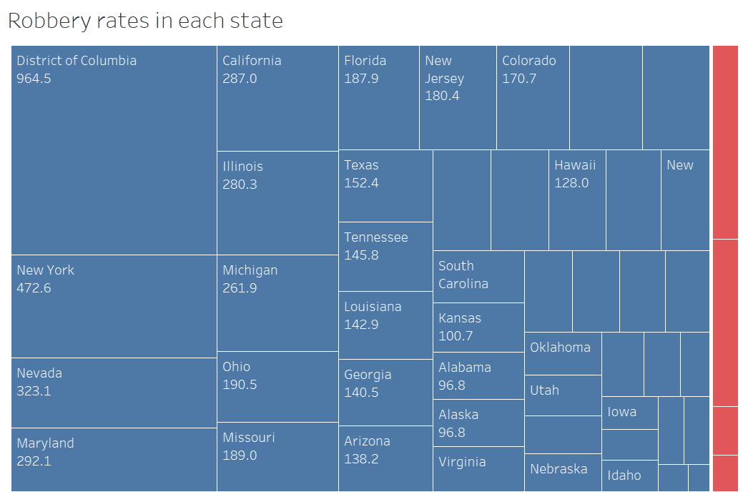

**1999**

Here again we see that District of Columbia has the highest robbery rate and the shall law was not issued through out.

Let us look at the state of Nevada the rate has reduced from 323.1 to 232.7.

This justifies the statement that issuing the law reduced crime.

But at the same time when we look at countries like Florida the robbery rate has increased from 187.9 to 211.6 after the law was issued.

This is because people may tend to misuse such laws to make easy money.

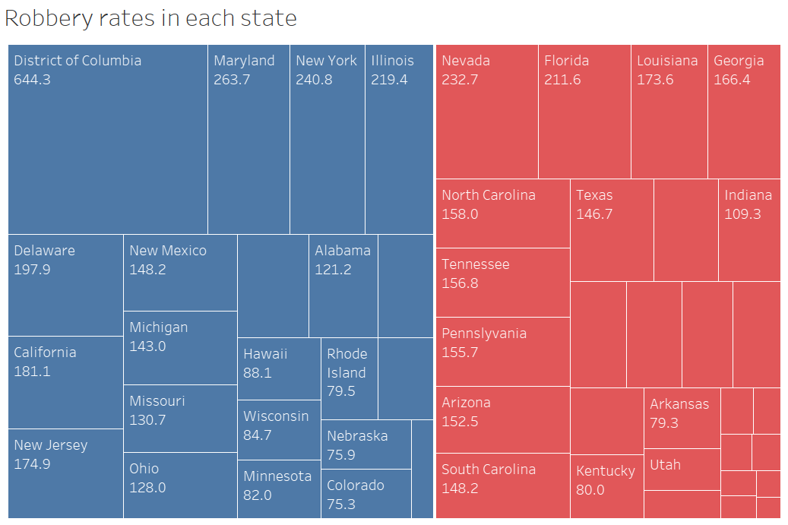

1. **Shall law issued states over the years**

From the pie charts below we clearly see that the number of states that have issued the shall law(red coloured) has increased from as low as 4 to 29 which is more than half of the total number of states.

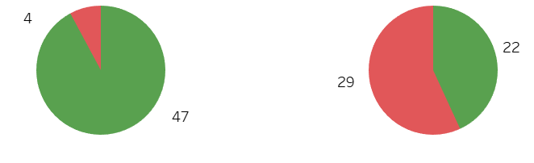 

Now, let us look at this increase year by year.

We see that over the first ten years that is from 1977 to 1987 the increase of number of states that issued the law was slowly increasing.

But after the year 1987 and especially from year 1994 to 1997 we see a drastic peak.

Bill Clinton was the president of the USA during that time.

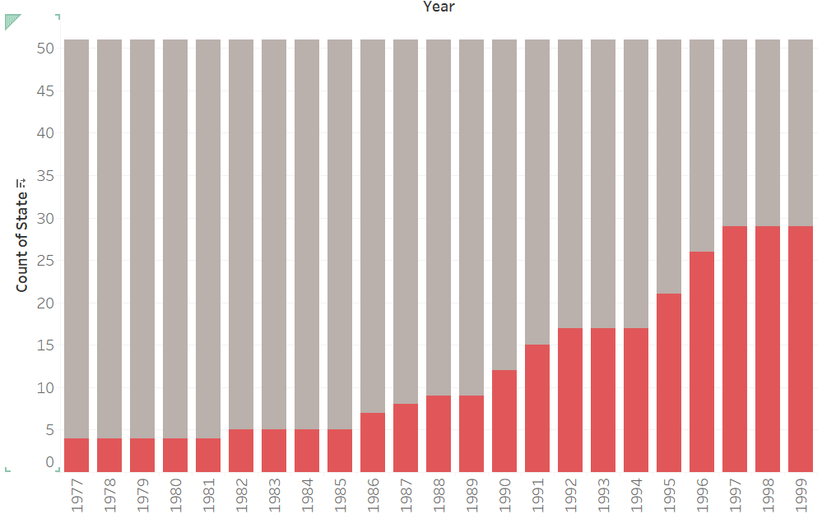

1. **Violent crime rate over the years**

This graph shows the overall violent crime rates over the years from 1977 to 1999

The highest peak of crimes can be observed during the years 1992 to 1994 and then decreased as an inclined line.

This inclination is observed during the same period where the shall law has been issued increasingly.

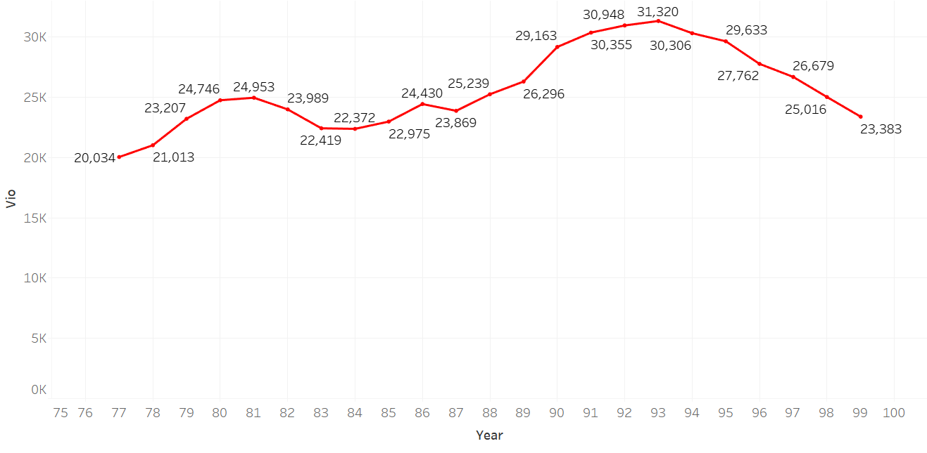

1. **Has incarceration effected violent crimes?**

Incarceration is the state of being confined in prison; imprisonment.

Imprisonment creates a kind of fear among people and we expect the crimes to reduce as the incarceration rate increases.

Let us look at the following graphs which show the incarceration rate along with violent crime rate, murder rate and robbery rate.

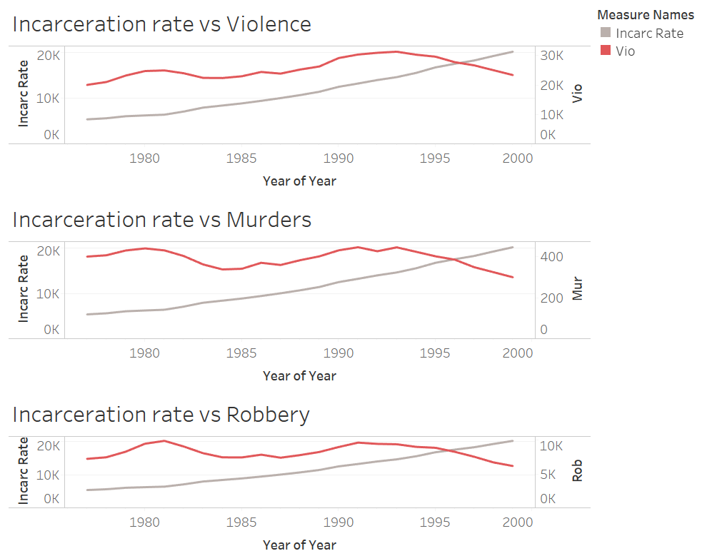

* As the incarceration rate increased over the years, the violent crime rate has not decreased until the year of 1995.
* Same is the case with murder rate but the robbery rate that has been steady over the years reduced after 1995 in the same fashion.

1. **Whites vs blacks violence over years**

-The effect of population of blacks increase the crime rate as compared to population of whites. Competitive society in which there is an inequality in the distribution of goods, those groups with limited or restricted access to goods will be more likely to turn to crime.

- In the below graph we observe that the percentage of whites of ages between 10 to 64 has been constant represented by the green line and the crime rate has seen some ups and downs.

-But the percentage of blacks of ages between 10 to 64 has increased slowly and the crime rate has seen ups and downs.

-From these visualisations we can’t confirm that increase in percentage of blacks increases crime rates.

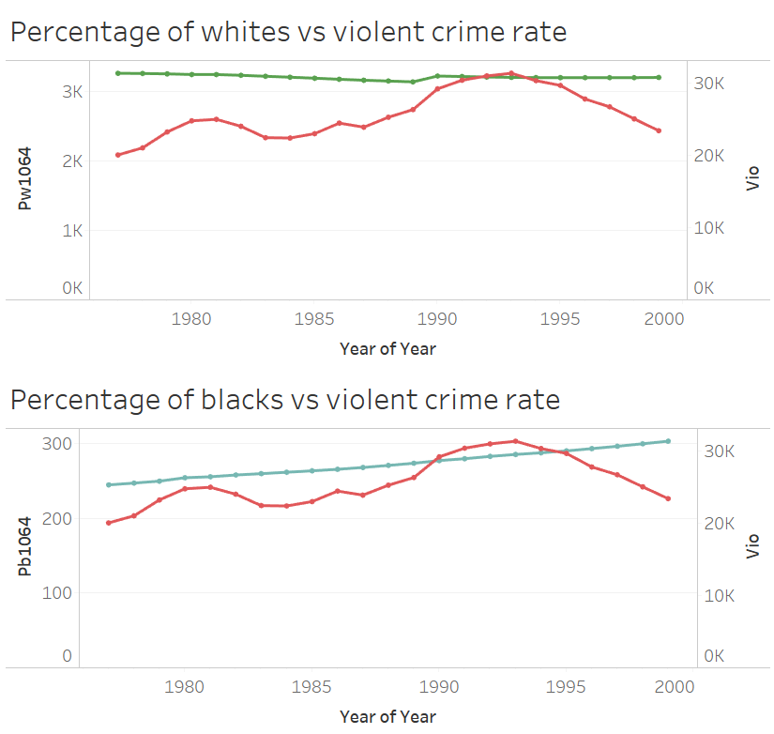

1. **Crimes before and after shall law was issued**

We believe that the crime rates have been reduced after the issuance of shall law. This is explained by states like Maryland.

In the below graph grey line indicates the violent crime rate when the state has not issued the law and red line indicates violent crime rate after the state issued the shall law.

We clearly see the decrease in crimes after the law has been issued(in this case after 1981).

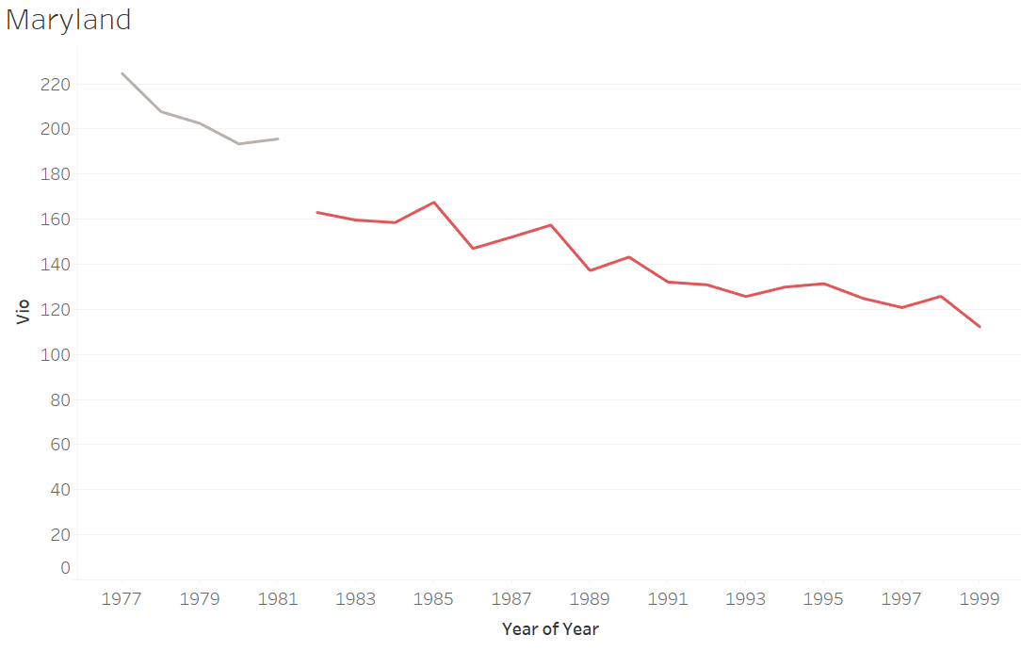

But In some other states like Virginia which is shown below the violent crime rate has increased after the shall law has been issued.

What fascinates us is the fact that there are other states like Virginia which include Nebraska, Rhode Island, Tennessee, etc.

This can be because of other factors affecting the crime rate and there may be an interaction effect that is acting up to give such results.

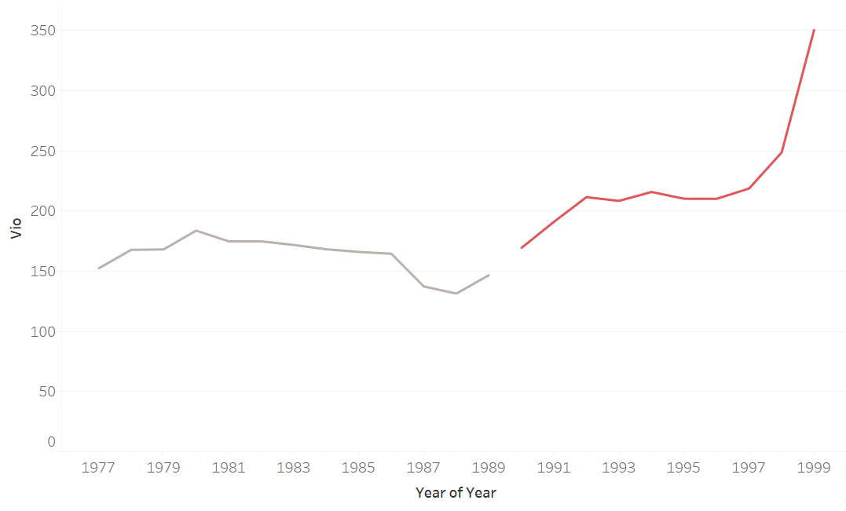

1. **States with vs without shall law from the beginning(1977)**

There are some states in which the law has not been issued from the beginning(1977) till 1999.

Let us look at the average violent crime rates( blue line) in those states.

These states include: Alabama, California, Connecticut, etc.

We see the crime rate does not show an increase or decrease alone but definitely by 1999 we see that the crimes have reduced.

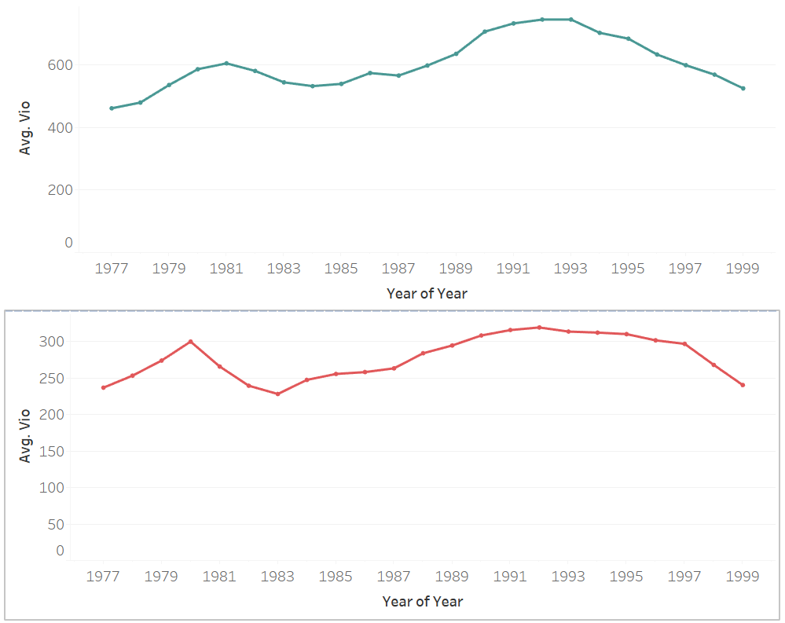

There are some other states where the law has been issued from the beginning itself.

We look at the average crime rates(red line) of these states.

These states include: Iowa, New Jersey, Texas and Vermont.

We observe that the crimes have increase gradually and then decreased.

Again this can be because of factors other than the law.

# UNDERSTANDING DATA

Based on analysis and intuition, our understanding and hypotheses of the data is as follows:

**Shall-Issue Law & Crime Rate:**

* Over the years, the number of states that implemented the *Shall-Issue* law has increased (from 4 to 29) which means there is a possibility that more states trust this law to be effective in bringing down the crime rate.
* Hence, we expect the *shall-law* variable to play a significant role in bringing down the crime rate like violence and murder.
* However, we feel that this might not be applicable to robbery since in general robbery, property crimes, theft and stealth are more associated with weapons like guns and is expected to increase when more people have access to them.

**Incarceration & Crime Rate:**

* Incarceration rate has always been increasing over the years. However, the crime rate is not perfectly negatively correlated with incarceration rate.
* Hence, it is hard to believe that incarceration rate has effectively brought down crime rate.
* In fact, we feel that incarceration rate increased because crime rate increased which could lead to a direct correlation.

**Population & Crime Rate:**

* We intuit that population density is a key factor in explaining crime rate as it is common to expect more crime happening in more densely populated areas.
* The percentage of whites in any state is always higher than that of black and we don’t find any meaningful relationship between race and crime rate or gender and crime rate.
* Thus, we expect *pm1029, pw1064* and *pb1064* variables to be less significant in explaining crime rate.

**DESCRIPTIVE ANALYSIS**